# MuleSoft - Consultant Exercise

We’re excited to move you forward in our Services interview process! The next step is to complete a technical exercise. This exercise is divided into below sections:

1. Developing a Mule API and Application based on the use case provided.
2. Demonstrate the API
3. Jamboard Session

You will then present to a small group of MuleSoft interviewers.

Before you begin Download Anypoint Studio [here](https://www.mulesoft.com/lp/dl/studio) and review some of the examples in Anypoint Exchange and understand how they work. Review information about MuleSoft’s platform, solutions, point of view, and services on [www.mulesoft.com](http://www.mulesoft.com).

Objectives Demonstrate your ability to:

* Use originality in developing an API and Application
* Outline the business problem you are solving
* Present your work to the MuleSoft team
* Extend and enhance your application in real-time

**Part 1: Use Case**

1. Create and Get Account Details from Salesforce CRM.
2. Embed best practices: Logging, Error Handling
3. Key point here is: Input has country code in the request for shipping and billing details tags, which needs to be looked up against [FIRST.org](http://FIRST.org) open source REST API to get the country name. (<https://api.first.org/data/v1/countries>) → **Look for the best solution which fits this implementation.**
4. Implement clientID enforcement policy with SLA based rate limiting. Limit 100 requests in a minute.
5. Make the best use of integration patterns
6. RAML link: [api.html](https://salesforce.quip.com/-/blob/EeYAAARuEWd/_DaHi_EePonIGSu--WVilw?name=api.html)
7. Munits to be written
8. Deploy to CloudHub 1.0 **OR** ClodHub 2.0 using any mechanism you prefer- Mule Maven plugin or directly via Runtime Manager/Studio.

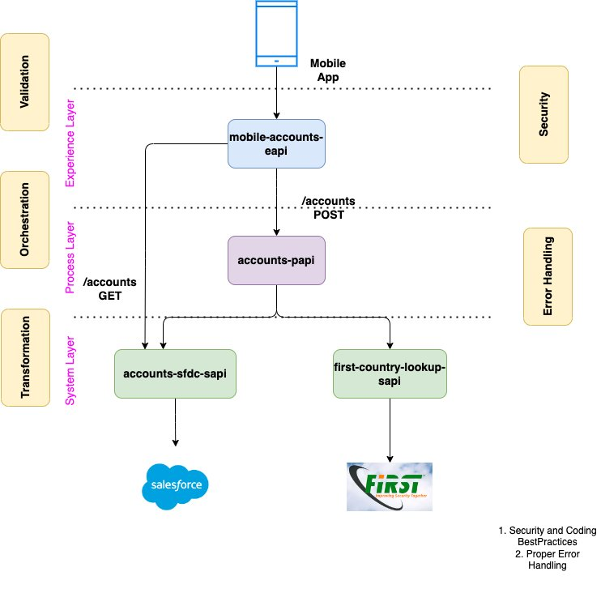

Using Anypoint Studio, design and develop an application that demonstrates an understanding of API and integration concepts. Your working application should demonstrate originality and your knowledge of MuleSoft.

You can use several modules, that are required for the usecase.

**Note:** We are not looking for an edited Mule sample but an original solution that

should include but is not limited to:

* Error handling
* Process orchestration
* Data transformation
* Testing of the solution

We will be evaluating different aspects of your solution, including professionalism of your work, creativity, and potential.

**Part 2:** Presentation

The presentation will be 60 minutes. Present your technical exercise to a small group of MuleSoft interviewers. We suggest that you allow 5 minutes at the start for introduction, 45 minutes for the API and Application demonstration and presentation, and 15 minutes at the end for questions.

**Document Submission:**

Once you have completed both Part 1, submit your work 3 hours prior to the scheduled session using the submission link provided to you by your Recruiter or Recruiting Coordinator.

Submit your work as a zip file with the following:

* Deployable application you’ve developed (configuration XML file, source files, documentation written, and others)

**Part 3:** Jamboard Session

You will be asked to provide on the fly solution for the use case provided during the Jamboard session for 15 minutes after the presentation round.